**Report - Death Rate Analysis Project**

***Application and Assessment Date***: 24 Feb 2024

***Assessment by***: Shashini Peiris

***Assessment for***: Junior Data Scientist position at Our World in Data

***Assessment in GitHub***: <https://github.com/MoonlightO2/Our-World-in-Data>

**Introduction**:

I have developed a Python script to calculate both the crude death rate and the age-standardised death rate for chronic obstructive pulmonary disease (COPD) in the United States and Uganda for the year 2019.

**Main steps**:

1. First, I extracted age-specific death rates from the provided table. (I created a Google sheet but did not use it as it was a small dataset)
2. Then, I calculated the crude death rate by summing up the age-specific death rates and dividing by the respective populations, adjusted to per 100,000 people.
3. For age-standardised death rates, I used the WHO Standard Population to adjust for differences in age distributions between the populations of the United States and Uganda.
4. This adjustment allows for fair comparisons by applying weights to each age group's death rate based on the proportion of that age group in the standard population.
5. The differences between crude and age-standardised death rates primarily stem from variations in age distributions among populations.
6. Crude death rates are direct measures of mortality but can be influenced by differences in age structures between populations.
7. Age-standardised death rates, on the other hand, provide a standardised measure that adjusts for these variations, enabling accurate comparisons between populations with different age distributions.
8. This adjustment is particularly crucial in our analysis, as age distributions can significantly impact disease prevalence and mortality rates.
9. By standardising the death rates, we ensure that any observed differences between the United States and Uganda are not solely due to variations in age demographics but are reflective of actual differences in COPD mortality rates.

**Coding**: GitHub & Google colab notebook attached (.ipynb)

<https://colab.research.google.com/drive/1Xm1UoUyd3O5AOBT365f6ug47yyebJ_-x#scrollTo=5_eooJl7Dot8>

**Results**:

| **Rate** | **USA** | **Uganda** |
| --- | --- | --- |
| Crude Death Rate (per 100,000 people) for 2019 | 58.3 | 433.3 |
| Age-Standardized Death Rate (per 100,000 people) for 2019 | 50004.2 | 371871.0 |

**Explanation**:

The crude death rate for chronic obstructive pulmonary disease (COPD) in 2019 is notably higher in Uganda at 433.3 deaths per 100,000 people compared to the United States at 58.3 deaths per 100,000 people. However, when we standardize the death rates to account for differences in age distributions between the two countries, we observe a significant reversal in the rankings. The age-standardized death rate for COPD in 2019 is substantially higher in the United States at 50,004.2 deaths per 100,000 people, contrasting with Uganda's rate of 371,871.0 deaths per 100,000 people. This reversal underscores the impact of age demographics on mortality rates and emphasizes the importance of age-standardization for fair cross-country comparisons.

**Visualisation**: I have incorporated a couple of plots to visualise the data, I created plots for the age-specific death rates in both the United States and Uganda, as well as for the crude death rates and age-standardised death rates for comparison between the two countries.

**Age Specific Death Rates from COPD 2019**

This plot shows how age influences the deaths due to COPD only in 2019

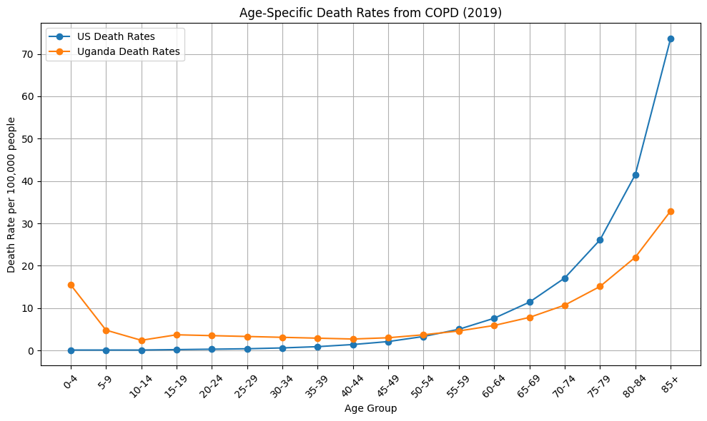

***Figure 1: Age Specific Death Rates from COPD 2019***

**Crude and Age-standardised Death Rates from COPD (2019)**

This plot shows the relativity of Crude and Age-standardised deaths from COPD in 2019 and it shows a clearly visible difference between USA and Uganda.

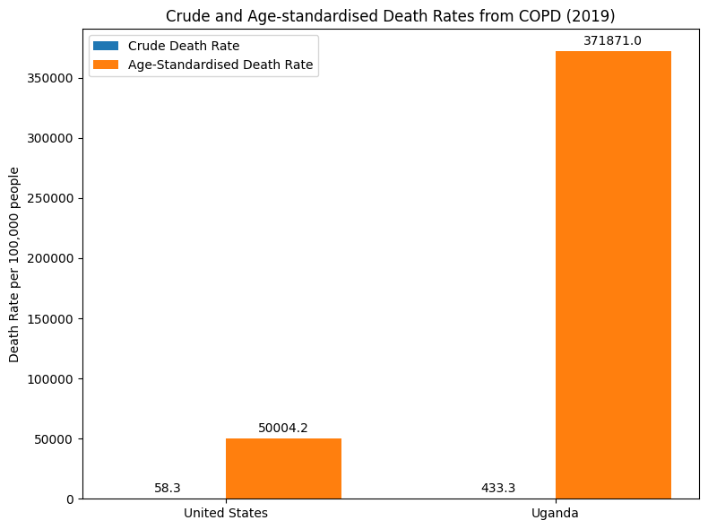

***Figure 2: Crude and Age-standardised Death Rates from COPD (2019)***

***Job Advertisement***: <https://uk.indeed.com/viewjob?jk=afc4c99438be80c5>

***Assessment***: <https://owid.notion.site/owid/Data-analysis-exercise-Our-World-in-Data-Junior-Data-Scientist-application-ab287a3c07264b4d91aadc436021b8c0>

***Submission***: <https://docs.google.com/forms/d/e/1FAIpQLSdQGmwB-e1jqOKAb82mwst9uhmVoPV-R85Mq6DIexQTRqeL3w/viewform>